

**CSIS 2124**

**Multimedia Development**

**Title: Zoro Game**

|  |  |
| --- | --- |
| **Student** | **Student ID** |
| Ilevarasar Veerapandiya Taragaessuran A/L Mahendran | D190019A |
| Ng Shu Ling | D190038A |

**Lecturer: Pang Yee Yong**

**4th SEPTEMBER 2020**

**Department of computer Science**

**Introduction**

In our project we used Adobe animate to develop a game. The objective for the user of our game is to type the words that appear on the screen by using their keyboard. We named the Game as Zoro game and designed the Game where when the user make mistake while typing the letter it will create an alert sound The game is developed as the user can play next level only when they successfully complete the previous level.

The main objective of this Zoro game is to help the user to improve the timing of typing. Our game is suitable for all the age group as it helps them to improve the speed of typing. The other objective of our game is to help the user to improve their focus because we believe that our game is required hand-eye coordination. The user actually need to focus on the screen instead of looking at the keys. Thus our Zoro game helps the user to build muscle memory and learn to type without looking at the keyboard.

1. Analysis

This Game was created for college students. All the students are from various states and different faculty. All the students are required to use the computer and Technology skills vary depending on the prior experience. Some student may not familiar with using computer and some of them might have slow typing skill. The Task that provide by our Zoro game is very simple and understandable by everyone. The task designed to perform six times per level as the level increase the letters to type will be difficult.

1. Design

This is the design of our game

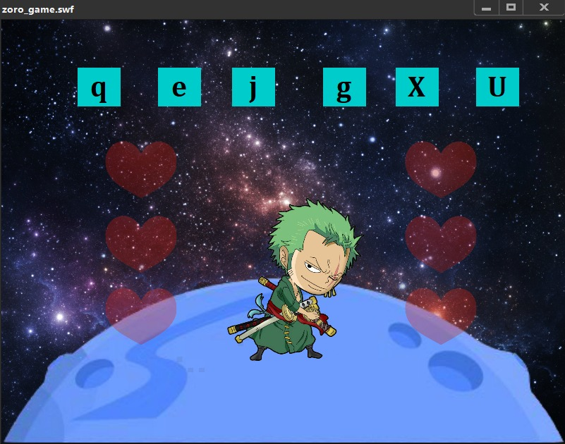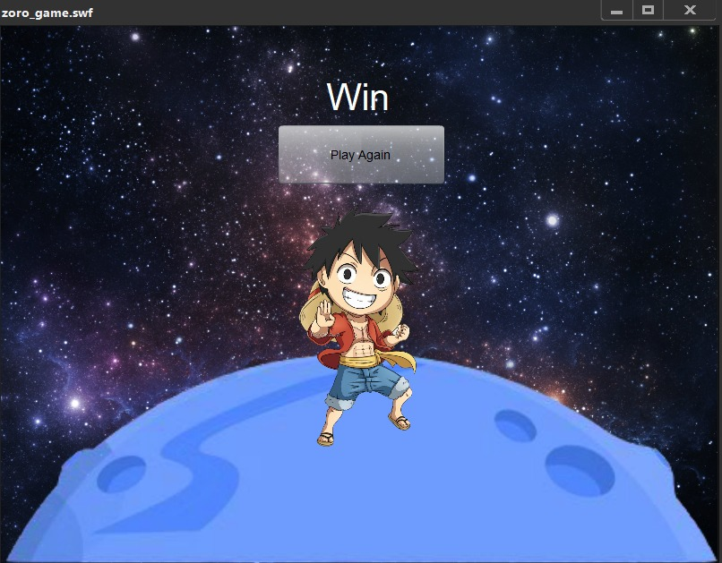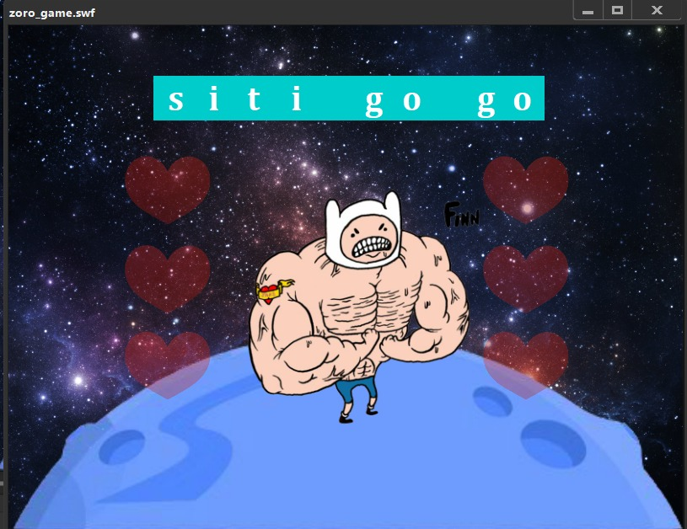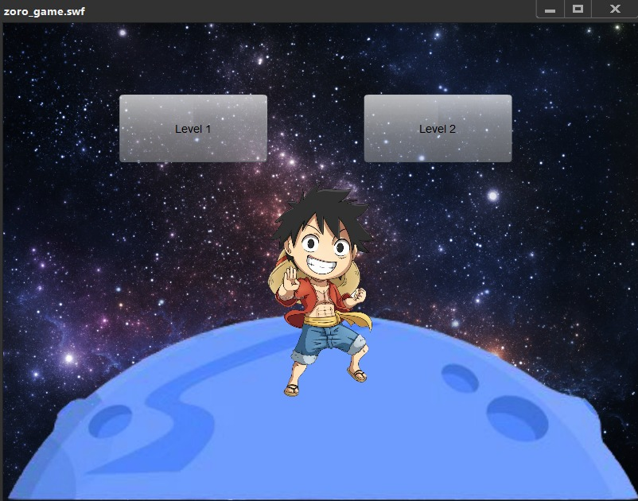

1. Development

|  |  |  |
| --- | --- | --- |
| Time | Planning Stage | Activity |
| 3 day | Research | Research the ideas for the project and collect the material for the design |
| 4 day | planning | Planning of the project about how we going to do it |
| 1 week | Create design and function | Creating the game design and the function using adobe animate (action script ) |
| 2 days | Creating report | After the final revision created the report for the project |

1. Evaluation

Our team has learn a lot of things from this development project. Designing was very interesting as we had an opportunity to turn our imagination to be developed into a fun game. It was time consuming to create but it was worth the investment of time. Our team members were able to learn some new technology skills. We believe this is a useful game which will help people to develop their typing skills. We also planned to create time count that record the time taken for the user to complete the typing of letters in future so it will be more fun .